Visualisation and network analysis in physical activity and its determinants: Baseline associations in the Let’s Move It trial

|  |
| --- |
| Matti T. J. Heino^1,2*^, Eiko I. Fried3, Reijo Sund1,4, Ari Haukkala1, Keegan Knittle1, Katja Borodulin1, Antti Uutela1, Vera Araujo-Soares5, Tommi Vasankari1, & Nelli Hankonen1 |
| 1 Faculty of Social Sciences, University of Helsinki |
| 2 Faculty of Social Sciences, University of Tampere |
| 3 Department of Psychology, Columbia University  Eiko: Department of Clinical Psychology, Leiden University  4 Institute of Clinical Medicine, University of Eastern Finland  5 Institute of Health and Society, Newcastle University, UK |
|  |

# Author note

Trial Registration Number: ISRCTN10979479. Registered retrospectively: 31.12.2015

Correspondence concerning this article should be addressed to Matti T. J. Heino . E-mail: [matti.tj.heino@gmail.com](mailto:matti.tj.heino@gmail.com)

Abstract

Background: Let’s Move It is a cluster-randomised controlled trial evaluating a complex whole-school intervention aiming to reduce sedentary behaviour (SB) and increase physical activity (PA) among older adolescents in vocational schools, by targeting environmental and psychosocial determinants of the phenomena. This paper describes the characteristics of its baseline cohort in both study arms exploring possibilities for visual presentation and making use of recent developments in software and network analyses. We provide an example of a comprehensive research report with all analysis code and result in a readily accessible format, for researchers to apply these tools to other data. Methods: At baseline, 1123 adolescents in 57 classes at 6 school units participated the study. Data were gathered with 7-day accelerometry, bioimpedance measures and questionnaires, used to measure health status, activity behaviours, and psychosocial constructs possibly mediating effects of the intervention on outcomes. Data were visualized using various techniques, e.g., combining ridge plots and diamond plots. Network analysis was used to investigate relations between psychosocial variables and outcomes. Results: Age of the participants ranged from 16-49 years (M = 18.8, Md = 17.0). On average, they engaged in moderate-to-vigorous daily PA for 1h 29min ( CI95: 1h 19min - 1h 40min), SB for 9h 34min (CI95: 8h 56min - 10h 12min), and interrupted sitting 28 times (CI95: 24.7 - 31.4) per day on average. Participants across the four educational tracks differed on several dimensions. No such differences were found between intervention and control groups. Spontaneously occurring behaviour change technique (BCT) usage was reported low for many but not all techniques. In network analysis with a network consisting of BCTs, motivation and PA, we found behavioural experiments, planning and autonomous motivation to be directly related to PA, and several BCTs to be connected via autonomous motivation. Conclusion: Grasping the dynamics of complex multicausal systems is a formidable task, unfolding of which can be aided by network analysis. We discuss benefits of presenting complex data visually to encourage researchers to publish extensive analyses and descriptions as website supplements. That would increase speed and quality of scientific communication, and may address recent concerns of reduced confidence towards research findings.

*Keywords:* exercise, physical activity, school-based intervention, behaviour change, sedentary behaviour

Word count: X

Demonstrating opportunities of visualisation and network analysis in physical activity and its determinants: Baseline associations in the Let’s Move It trial

# Background

Declining physical activity (PA) and increasing sedentary behaviour (SB) are costly and growing concerns for public health, especially among individuals from a low socioeconomic status (SES) [1]. Patterns of low PA among adults start to develop early on during life course. As there is evidence that declines in PA and increases in SB are already evident in childhood and adolescence [3, 4], there is a need for further research on to how to improve PA and SB among adolescents.

As adolescents spend a significant amount of their time in schools, these contexts provide a promising opportunity for PA and SB interventions [5]. The Let’s Move It intervention aimed to reduce SB and increase PA among adolescents in vocational schools; developed using stakeholder input and co-creation with target group representatives, as well as behavioural science theory and empirical evidence [6, 7]. Contrary to typical school-based interventions with relatively more homogeneous participants, this trial was carried out in vocational schools with quite distinct educational tracks (i.e. practical nurse, business information and communication technology, business administration, hotel, restaurant and catering). Understanding the implications of these distinct tracks on the way participants engage in both PA and SB will support a better understanding of the individual and contextual determinants of behaviour and also for a more informed interpretation of the results obtained the trial (ref outcome ppr).

The programme theory (described and explained in REF: DEVELOPMENT; see also [8]; [9]; <https://mrc.ukri.org/documents/pdf/mrc-phsrn-process-evaluation-guidance-final/>, p. 32) for changing PA and SB was hypothesised to be slightly different for each target behaviour . In order to engage in PA, one needs to make a conscious effort and implement self-regulatory skills to make use of any emerging opportunities. Skills such as planning for active times and overcoming barriers to exercise are often enacted. In the intervention that was developed, ‘Let’s Move it’, one of the key emphases in helping adolescents change their PA was to help them understand and use techniques to manage their motivation and behaviour (see also [10]). To date, there is little systematic theorising on how the use of these techniques link to each other, and it would be important to identify these links empirically. The theoretical model for changing SB, on the other hand, is more driven by opportunities and incentives, such as having the option of standing up during class.

In order to change moderate-to-vigorous-intensity PA, a central component of the intervention targeted autonomous motivation, social cognitions, as well as participants’ skills to use behaviour change techniques for self-regulative motivation and behaviour (Hankonen et al, unpublished manuscript). The mediators postulated by the program theory included behavioural beliefs (outcome expectations, descriptive norms, intention, self-efficacy/perceived behavioural control), autonomous and controlled motivation, environmental opportunities, action and coping planning, and behaviour change technique (BCT) use. Key hypotheses regarding students’ PA change have been registered in OSF (<https://osf.io/tb8fu/>). To reduce total SB and introduce breaks in SB, the program aimed to change the school environment by training teachers in the use of active teaching techniques and altering physical choice architecture in classrooms (Köykkä et al, accepted). The intervention included also poster campaigns in schools and a website, as well as materials to target community actors and parents such as XXXX[11]. More information of the content of the intervention and the development of it is reported elsewhere (Hankonen et al 2017 NELLI?), Hankonen et al unpublished manuscript).

It has long been a standard recommendation for quantitative analyses to investigate data visually as a core precursor of conducting statistical analyses [12, 13]. However, in social and life sciences, such visualisations have rarely been shared in publications. Information about data are usually limited to means and standard deviations, which presents at best limited information about the variables of interest. Medians, modes, skewness and kurtosis provide helpful additional information, but can still hide important distributional properties.

Data visualisation is crucial to supplement possibly large numerical tables of descriptive statistics (REF GRAPHICAL DESCRIPTIVES). With visualisations, researchers can communicate large amounts of information -- including the associated uncertainty -- in an accessible format, without requiring extensive mathematical expertise from the reader. This is important for researchers who intend to build on previous results (REF indadequate reporting). Such practices may be a way to reduce problems that have led to the recent loss of confidence in the reproducibility and replicability of research findings [14–23]. The ideal would be to share fully open data, but this is not always possible due to privacy concerns (REF Expert Advisory Group on Data Access, 2015) and, at the time of writing, a lamentably rare practice (REF Vanpaemel Wasting Crisis). In addition, open data does not necessarily accommodate stakeholders with low technical expertise in data analysis and visualisation, such as clinicians, patients and policy makers (REF Hallgren 2018 path model visualisations, p. 2).

Three recent developments give impetus to a new approach. First, many journals now allow publication of supplementary online materials, which circumvents both word and figure restrictions of traditional manuscripts. Second, statistical software such as R [24] has recently become increasingly mainstream among applied researchers, with many free tutorials available online, opening the door also for a variety of data visualisation techniques. Third, novel statistical methods in social and health psychology, such as psychological network analysis, may help to understand relationships between variables, by making better use of visual representations of associations.

The aims of this paper are to describe the central characteristics of the Let’s Move It trial baseline cohort, focusing on the co-primary outcomes and other activity measures (as measured by accelerometry) of the trial both arms, genders and educational tracks of the trial. In doing so, we provide a rationale for the importance of data visualisation, discuss its advantages and recent developments in scientific publishing, statistical software, and statistical models that enable researchers to use data visualisation tools more easily and efficiently. A further aim is to describe psychosocial correlates and hypothesised mediators of the intervention effect on moderate-to-vigorous physical activity, with detailed visualisations of the dataset provided in an extensive supplement. As a subaim, we also investigate network of relationships between MVPA, quality of motivation and behaviour change technique use at baseline. We provide all code as open source scripts so that other researchers can use those scripts as templates to deliver visualized information in a format which only requires a web browser to be viewed.

All conducted analyses and visualisations with accompanying code, can be found in the supplementary website at <https://git.io/fNHuf> (permalink at [REF]). Source code to reproduce this manuscript itself can be found at [REF].

# Methods

Details of LMI-study and its protocol have been described earlier [11]. In brief, the study was a cluster-randomised controlled trial of a complex whole-school multi-level intervention conducted in Finnish vocational schools. The consenting participants answered an electronic survey, underwent bioimpedance measurements and were instructed to use an accelerometer for seven consecutive days.

Six school units were included in the study. There were four educational tracks in the schools from which students were recruited: 1. Practical Nurse (Nur), 2. Hotel, Restaurant and Catering (HRC), 3. Business and Administration (BA), and 4. Information and Communications Technology (IT). Schools were paired so that there would be matching numbers of students from each educational track for both members of the pair. Blinded randomization by a statistician without knowledge of pairs, track or schools was then conducted so that a random member of each pair was selected as intervention school, the other as control school (details reported in [11]). Participants were blind to randomisation at baseline.

## Measures

The measures used in the study have been previously described in [11], and all individual items of the scales are available in the supplementary file [MATTI TODO]. Thus, we will describe these measures only briefly here.

### Primary outcome variables

The primary outcome for PA was moderate-to-vigorous intensity physical activity (MVPA). It was measured by accelerometry and self-reports. Primary outcomes for sedentary behaviour (SB) were measured by the accelerometer. They included time spent sitting or lying down, and the number of times sitting was interrupted during a day.

*Self-reported MVPA.* Self-reported MVPA was measured with two questions in accordance with the NordPAQ measurement [25]. The first question asked participants about the number of days during the last week in which they did more than 30 minutes of MVPA, the other probed the overall amount of MVPA (in hours) during the past seven days.

*Accelerometer-measured MVPA.* No more than seven days after responding to the questionnaire, students were given an accelerometer to be worn on seven consecutive days. The hip-worn accelerometer (Hookie AM 20, Traxmeet Ltd, Espoo, Finland) using a digital triaxial acceleration sensor (ADXL345; Analog Devices, Norwood MA) was attached to a flexible belt and participants were instructed to wear the belt around their right hip for seven consecutive days during waking hours, except during shower and other water activities. The acceleration signal was collected at 100 Hz sampling frequency, ±16 g acceleration range and 0.004 g resolution. PA-parameters were based on mean amplitude deviation (MAD) of the resultant acceleration analysed in 6s epochs [26]. The MAD values were then converted to metabolic equivalent (MET) values [27]. The epoch-wise MET values were further smoothed by calculating 1min exponential moving average [**TOMMI CHECK if 1min moving avg or 6s epoch exponential moving average**]. Using the smoothed MET values total PA was classified in terms of energy consumption covering MET values higher than 1.5 and moderate-to-vigorous PA (MVPA) covering MET values equal to or higher than 3 [26, 27].

*Sedentary behaviour.* According to the definition of SB [28], time spent in sitting and reclining positions were combined to indicate SB, whereas standing was analysed separately as another form of stationary behaviour. Body postures were recognized from the raw acceleration data by employing both direction and intensity information from all three measurement axes. The recognition was based on the low intensity of movement (<1.5 MET) and the accelerometer orientation in relation to identified upright position (angle for posture estimation, APE) calculated at the end of each 6 s epoch [29].

### Theoretical predictors of PA

The mediators postulated by the program theory included behavioural beliefs (outcome expectations, descriptive norms, intention, self-efficacy/perceived behavioural control), autonomous and controlled motivation, opportunities, action- and coping planning, and behaviour change technique (BCT) use. Participants were allowed to skip questions, and scales were computed as means of all items where responses were available. **In other words, answering a single item sufficed.** All items, response options, and descriptive statistics of scales are available in the supplementary website (https://git.io/fAj0e).

### Statistical analysis

Rstudio (VERSION) [30] was used, running R (VERSION) [31] in all our analyses and figures.

Psychological network analysis was used to estimate and visualise relations among variables. Such networks contain nodes (variables) and edges (statistical relationships between variables). Unlike in social network analysis, the connections are not directly observed, but are estimated. We used network models that estimate conditional dependence relations among a set of variables, which can be interpreted akin to partial correlations. An edge between two variables implies that they are related after controlling for all other variables; the absence of an edge implies that the two variables are (conditionally) independent.

Network analysis has recently been taken up in many fields such as social psychology [32, 33], personality [34], intelligence [35], psychopathology [36], and empathy research [37], and is beginning to be applied for health behaviours on a broader scale. Several helpful tutorial papers are available for empirical researchers working in psychology ([38]; [39]; [40]; [41]; [42]], and health psychology in particular (REF HEVEY TUTORIAL).

Network models applied to between-subjects data at one time-point can be useful for describing health psychological data, as well as facilitating group-level hypothesis generation regarding which parts of the system are central for a problem at hand [43]. Identifying these determinants of importance can thus supplement traditional structural equation modeling (SEM) while alleviating problems with some commonly practiced approaches to SEM [44, 45], which is why we opt for the networks approach here.

Network analysis naturally entails its own set of assumptions. As with any model, it does not make sense to include variables which can be thought to be embedded in each other. For example, it is difficult to argue that there is no conceptual overlap between *positive outcome expectations* and *autonomous motivation*. In this regard, *behaviour change technique usage* and the *quality of one’s motivation* (as posited by self-determination theory) seem less problematic. To ease interpretation and facilitate analysis, in the case of the model presented here, we dichotomised heavily skewed controlled forms of *motivation* (introjected & extrinsic) such that if a person answered 3 or higher (at least partly, or more true for me), 1 was inputed while 0 was used otherwise. In addition, behaviour change techniques were dichotomised so as to inpute 0 if a person reports completely disagreeing with their statements or never having used them.

The Mixed Graphical Model we employed here uses regularization, a procedure that has been shown to help recover the true network structure in data in case the data were simulated under a network model (REF Haslbeck & Waldorp 2015). Regularization has the goal to avoid estimating spurious relationships among items (i.e. false positive relations), and results in a parsimonious network structure. The regularization technique used here is the Least Absolute Shrinkage and Selection Operator (LASSO; [46]), which shrinks all edges and sets very small edges to exact zero. A paper that explains LASSO regularization in network models in detail can be found elsewhere [39].

# Findings

Table 1 shows the main demographic variables of the cohort by educational track. Most (83.1%) participants were born in Finland. While on average the sample consist of both boys and girls (43.5% vs. 56.5%), educational tracks were heavily divided by gender: Practical Nurse track had the highest percentage of girls (82.3%) and IT track the lowest (16%). Age ranged from 16 to 49, with the average age of 18.50 years. Altogether there were 190 students who reported being at least 20 years.

Table 1

*Baseline demographics of educational tracks. Nur = Practical nurse, HRC = Hotel, restaurant and catering studies, BA = Business and administration, IT = Business information technology. Omitted are 24 participants, who reported “other” as their track, as well as 81 participants from whom the data is not available.*

|  |  |  |  |  |  |
| --- | --- | --- | --- | --- | --- |
| Variable | Nur | HRC | BA | IT | Full sample |
| n | 402 | 213 | 282 | 163 | 1165 |
| Mean study year (sd, median) | 1.7 (0.9, 1.0) | 1.9 (0.7, 2.0) | 1.7 (0.9, 1.0) | 1.7 (0.9, 1.0) | 1.7 (0.9, 1.0) |
| Mean age (range, median) | 18.8 (16.0-49.0, 17.0) | 18.5 (17.0-27.0, 18.0) | 18.0 (16.0-35.0, 17.0) | 18.5 (17.0-43.0, 17.0) | 18.5 (16.0-49.0, 18.0) |
| Born in Finland (%) | 80.0 | 88.2 | 87.1 | 87.9 | 83.1 |
| % girl | 82.3 | 60.6 | 39.0 | 16.0 | 56.5 |
| % allocated to intervention | 68.9 | 31.5 | 53.5 | 46.6 | 53.6 |

Table 2 shows summary statistics for primary outcome variables with their intra-class correlations (ICCs) for class and school (see supplementary website for ICCs for all variables). The ICC can be interpreted as the proportion of the variable’s variance, which can be accounted for by group membership.

At baseline, 79% students provided at least 4 days with a minimum of 10 hours per day of valid accelerometer data. On average, the youth reported engaging in at least 30 minutes of MVPA on 2.80 days a week.

Table 2

*Primary outcome variables with their class and school ICCs. Primary outcome variables highlighted with asterisks. Accelerometer results, including wear time, are only included from those participants who met the cutoff of at least 10 hours of measurement time for at least four days.*

|  |  |  |  |  |  |
| --- | --- | --- | --- | --- | --- |
| Variable | Mean | CI95 | ICC class | ICC school | n |
| Daily moderate-to-vigorous PA time (accelerometer)* | 1h 29min | 1h 19min - 1h 40min | .083 | .100 | 706 |
| Daily light PA time (accelerometer) | 1h 34min | 1h 26min - 1h 42min | .074 | .074 | 706 |
| Daily standing time (accelerometer) | 1h 32min | 1h 19min - 1h 45min | .140 | .098 | 706 |
| Daily time spent sitting or lying down (accelerometer)* | 9h 34min | 8h 56min - 10h 12min | .086 | .145 | 706 |
| Daily number of times sitting was interrupted (accelerometer)* | 28.0 | 24.7  -    31.4 | .058 | .085 | 706 |
| Number of days with >30 MVPA min previous week (self-report)* | 2.8 | 2.6  -     3.0 | .047 | < .001 | 1082 |

## Theoretical mediators: Traditionally presented results

In table 3, we present the means for the primary outcome variables by gender and intervention group. In our case (no confirmatory hypotheses), confidence intervals are more appropriate to report than p-values, as they provide readily interpretable values on the same scale as the original variable, accomodating inferences of practical relevance (REF Sterne 2001, Wasserstein & Lasar, Gardner & Altman, Nosek pre-reg rev),.

Table 3

*Main mediating variables of PA and SB*

|  |  |  |  |  |  |
| --- | --- | --- | --- | --- | --- |
| Variable | Girls | Boys | Intervention | Control | Total |
| PA action planning | 2.7 (2.6 - 2.8) | 2.8 (2.7 - 2.9) | 2.7 (2.6 - 2.8) | 2.8 (2.7 - 2.9) | 2.8 (2.7 - 2.8) |
| PA agreement-BCTs | 3.1 (2.9 - 3.2) | 3.1 (3.0 - 3.3) | 3.0 (2.9 - 3.2) | 3.2 (3.0 - 3.4) | 3.1 (3.0 - 3.2) |
| PA amotivation | 1.5 (1.4 - 1.5) | 1.6 (1.5 - 1.7) | 1.5 (1.4 - 1.6) | 1.5 (1.4 - 1.7) | 1.5 (1.5 - 1.6) |
| PA autonomous regulation | 3.3 (3.2 - 3.5) | 3.6 (3.4 - 3.7) | 3.3 (3.2 - 3.5) | 3.5 (3.3 - 3.6) | 3.4 (3.3 - 3.5) |
| PA controlled regulation | 1.9 (1.8 - 2.0) | 1.8 (1.7 - 1.8) | 1.8 (1.7 - 1.9) | 1.9 (1.8 - 1.9) | 1.8 (1.8 - 1.9) |
| PA coping planning | 2.4 (2.4 - 2.5) | 2.6 (2.5 - 2.7) | 2.5 (2.4 - 2.6) | 2.5 (2.4 - 2.6) | 2.5 (2.4 - 2.6) |
| PA descriptive norm | 4.3 (4.1 - 4.5) | 4.5 (4.4 - 4.7) | 4.3 (4.1 - 4.5) | 4.5 (4.3 - 4.7) | 4.4 (4.2 - 4.6) |
| PA frequency-BCTs | 2.5 (2.4 - 2.6) | 2.6 (2.5 - 2.7) | 2.5 (2.4 - 2.6) | 2.6 (2.4 - 2.7) | 2.5 (2.4 - 2.6) |
| PA injunctive norm | 4.6 (4.4 - 4.8) | 4.8 (4.5 - 5.0) | 4.5 (4.3 - 4.7) | 4.8 (4.6 - 5.0) | 4.7 (4.5 - 4.8) |
| PA intention | 5.3 (5.1 - 5.5) | 5.5 (5.2 - 5.7) | 5.4 (5.1 - 5.7) | 5.4 (5.1 - 5.7) | 5.4 (5.2 - 5.6) |
| PA opportunities | 5.1 (5.0 - 5.1) | 5.2 (5.1 - 5.3) | 5.1 (5.0 - 5.2) | 5.2 (5.1 - 5.3) | 5.1 (5.1 - 5.2) |
| PA outcome expectations | 4.7 (4.6 - 4.8) | 4.5 (4.4 - 4.6) | 4.6 (4.4 - 4.7) | 4.7 (4.5 - 4.8) | 4.6 (4.5 - 4.7) |
| PA perceived behavioural control | 5.2 (5.1 - 5.3) | 5.5 (5.4 - 5.6) | 5.3 (5.1 - 5.5) | 5.3 (5.1 - 5.5) | 5.3 (5.2 - 5.5) |
| PA self-efficacy | 5.1 (5.0 - 5.3) | 5.3 (5.2 - 5.5) | 5.2 (5.0 - 5.3) | 5.3 (5.1 - 5.4) | 5.2 (5.1 - 5.4) |
| SB descriptive norm | 3.2 (3.0 - 3.4) | 3.4 (3.1 - 3.6) | 3.2 (3.0 - 3.4) | 3.3 (3.1 - 3.5) | 3.2 (3.1 - 3.4) |
| SB injunctive norm | 4.0 (3.8 - 4.1) | 4.1 (3.9 - 4.3) | 3.9 (3.8 - 4.1) | 4.1 (4.0 - 4.2) | 4.0 (3.9 - 4.1) |
| SB intention | 3.8 (3.5 - 4.1) | 3.6 (3.3 - 3.9) | 3.7 (3.2 - 4.2) | 3.7 (3.3 - 4.2) | 3.7 (3.4 - 4.1) |
| SB outcome expectations | 4.5 (4.4 - 4.6) | 4.3 (4.2 - 4.4) | 4.4 (4.2 - 4.6) | 4.4 (4.3 - 4.6) | 4.4 (4.3 - 4.5) |

## Graphical presentation

Next, we present results graphically, to give the reader a richer perspective than what can be achieve considering summary statistics only.

### Activity during the day

From Figure 1, we can see that the patterns of baseline activity, as measured by the accelerometer, within gender and intervention allocation groups are similar, but the IT track differs in their activity pattern to some extent.

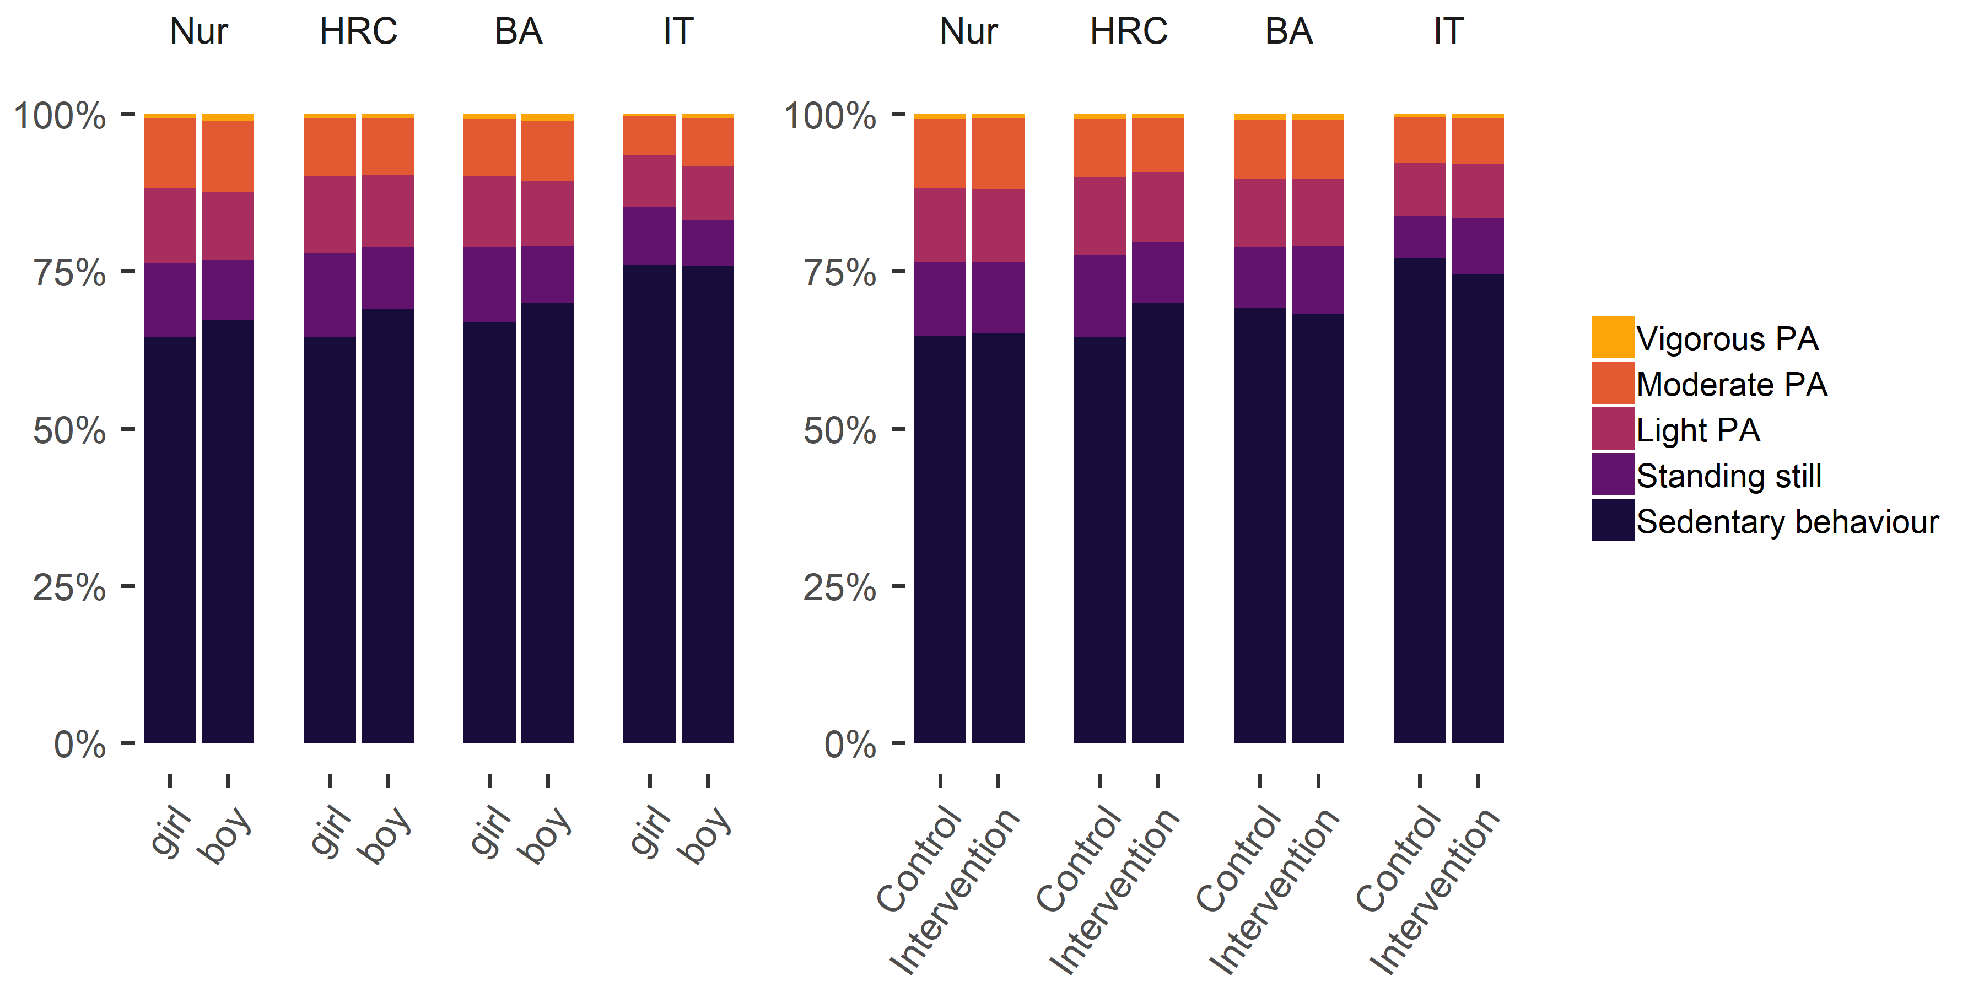

Figure 1 Stacked bar plot drawn with R package ggplot (code available at LINK), showing proportions of accelerometer-measured activity in relation to measurement time, averaged over genders, arms and educational tracks. Nur = Practical nurse, HRC = Hotel, restaurant and catering, BA = Business and administration, IT = Information and communications technology.

The plot shows the average activity types relative to measurement time, but hides all variability around the averages. The graph does not depict, for example, that while the average portion of time spent in sedentary behaviour was 68%, almost every fourth (23%) participant was sedentary more than 75% of the time.

Figure 2 displays a density plot. It can be read like a histogram, but the shape is not dependent on the bar width, which is often set by software defaults and may not reflect the research needs at hand. The density curve also helps illustrate differences across groups. This graph reveals variability and potential distributional differences, but does not show individual observations which determine the height of the curve.

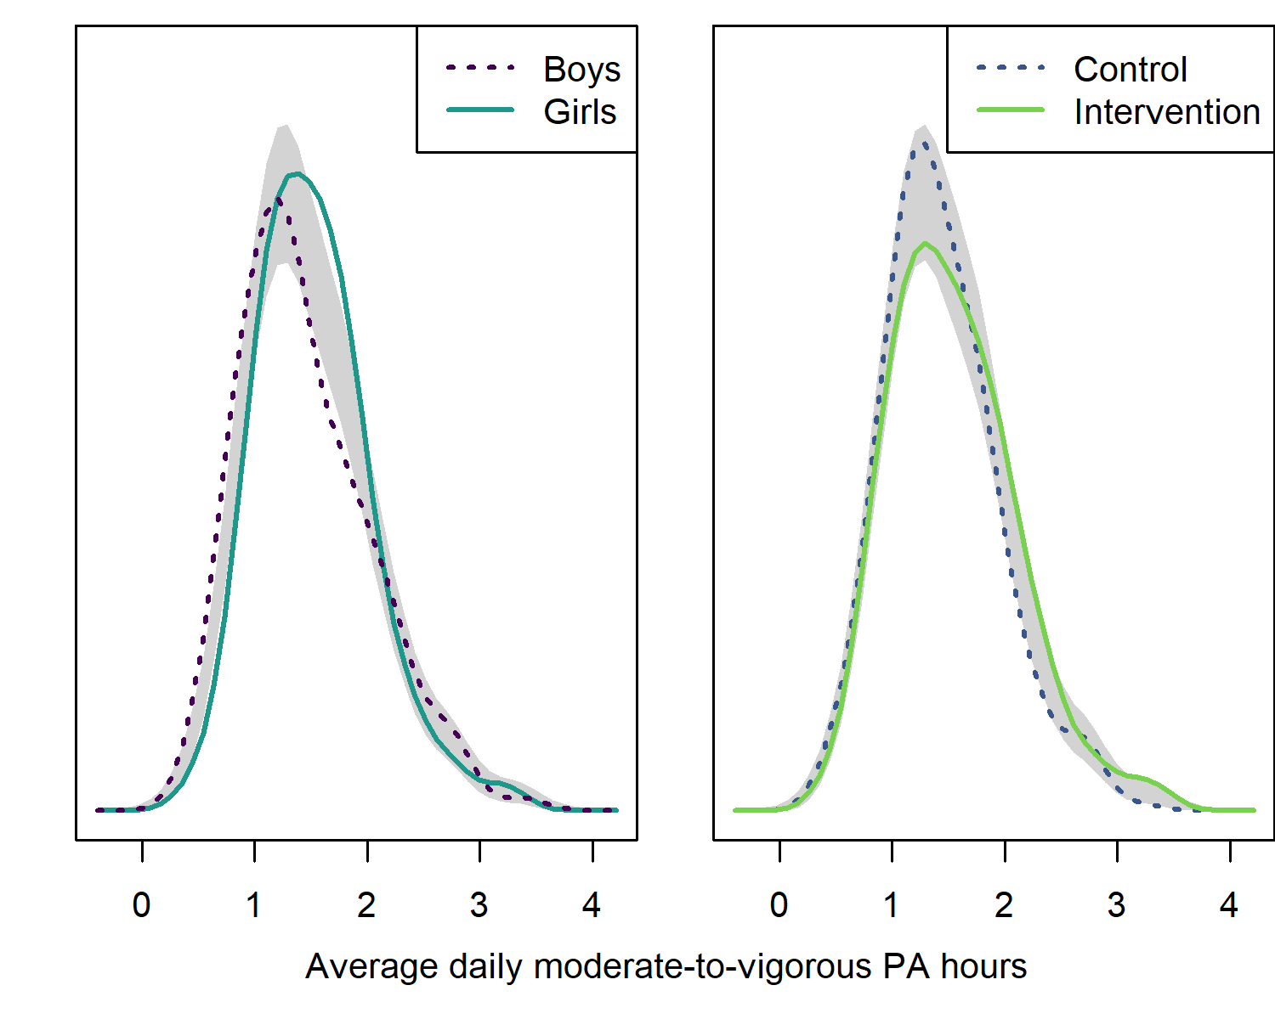

Figure 2 Kernel density plot drawn with R package sm (code available at LINK), showing accelerometer-measured moderate-to-vigorous PA minutes, separated by gender and arm. Grey region depicts bootstrapped area of equivalence, centred at the mean of curves at all points with a width of two standard errors (ICC not accounted for; REF Bowman & Azzalini, pp. 107-111).

We can see that girls seem to be slightly more active than boys (mean 92 vs. 87 minutes), or more specifically, there are more girls who reached an average of 1.5-2 hours of MVPA, and less of them who were lower. Although the grey band does not take clustering in classes, schools and educational tracks into account, it provides a heuristic for determining divergences between groups. Given that boys are generally more active than girls [3], this warrants a closer inspection, as presented by the density plots in figure 3.

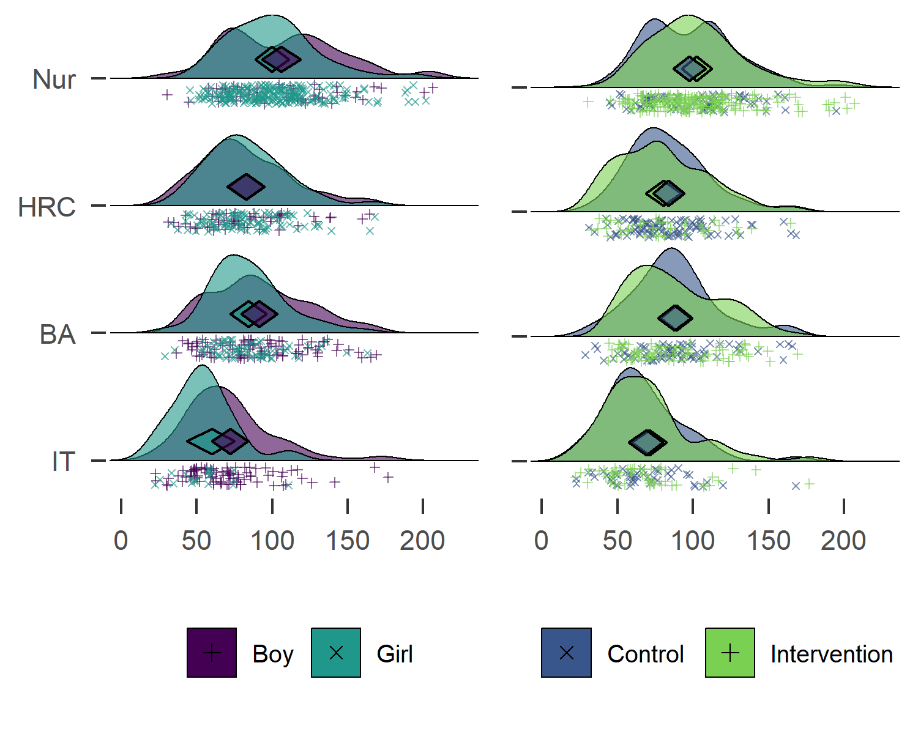

Figure 3 Raincloud ridge plot combined with a diamond plot, drawn with R packages ggridges and userfriendlyscience (code available at LINK), showing hours of moderate-to-vigorous PA for different educational tracks. Midpoints of diamonds indicate means, endpoints 95% credible intervals. Individual observations are presented under the density curves, with random scatter on the y-axis to ease inspection. Nur = Practical nurse, HRC = Hotel, restaurant and catering, BA = Business and administration, IT = Information and communications technology.

As can be seen from the x-axis placement of diamonds in figure 3, participants who study to be practical nurses are the most active, followed by HRC students and BA students, with the IT track being the least active, though there is considerable variation within tracks. This explains the difference in MVPA among girls and boys: the practical nurse track is the largest, and its students are most active, as well as mostly girls. The information technology students are the least active, and mostly boys.

In sum, boys were very actually slightly more active in most of the tracks, although mean differences in minutes (7.40 for Practical nurse, -0.40 for Hotel, restaurant and catering, 7.50 for Business and administration, and 17.10 for Information and communications technology) are small. In spite of this, girls appear more active in the whole. This is also known as the Simpson’s paradox, and—as seen in REF:figure3— is best approached by visualising data (see [54] for an introduction).

Similar plots for all primary outcome variables can be found in the supplement. In brief, regardless of track, boys reported more days with at least 30 minutes of MVPA, while reporting more e.g. gym training, which was more strongly connected to the self-reported MVPA than the accelerometer-measured one. Accelerometer measurement also indicated, that boys were more sedentary and interrupted sitting less often than girls. These results are also described in the supplement.

### Behaviour change technique usage

There were no clear differences between frequency-dependent BCTs between genders and intervention allocation, as shown in Figure 4.

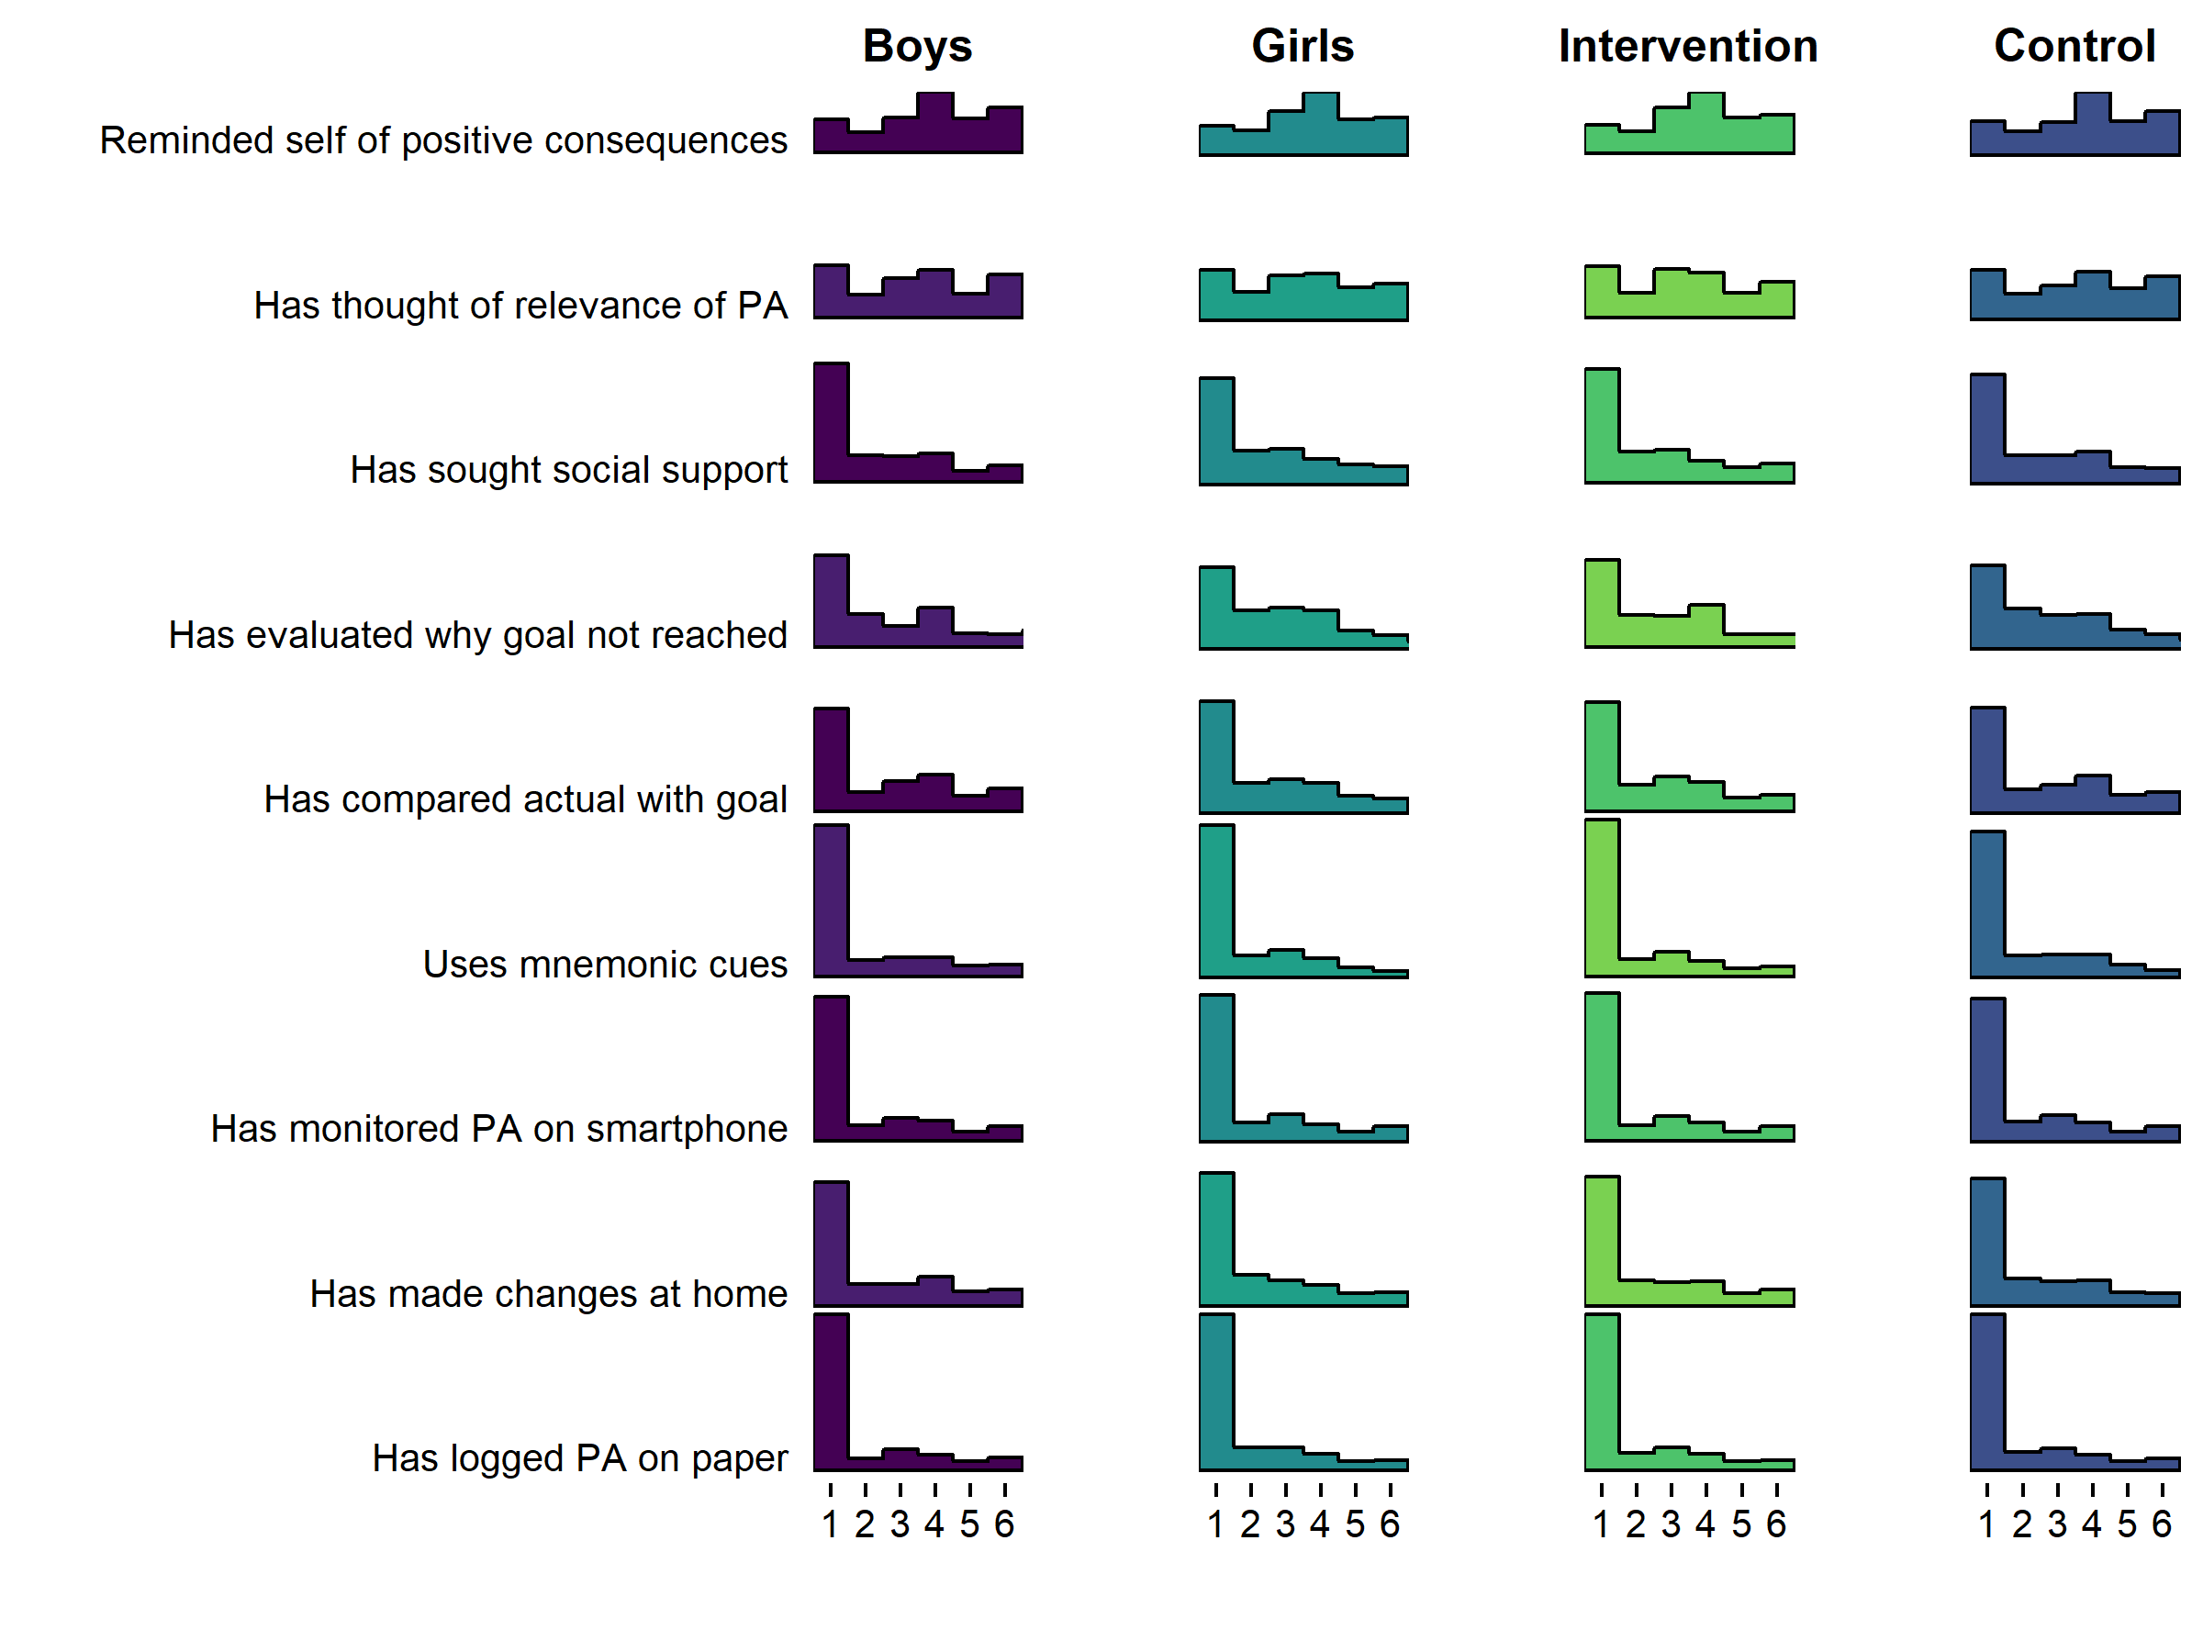

Figure 4 Histogram drawn with R package ggridges, showing self-reported use of frequency-dependent BCTs (1 = Not once … 6 = Daily).

Inspecting Figure 4 tells that the most frequent response is 1, indicating non-use of that BCT. In fact, a large number of BCTs seem to indicate a composite distribution, where one population reports never using the BCT, and another is seems normally distributed around the middle of the scale.

The aforementioned forms can also be observed in the distributions of agreement-dependent BCTs, as presented in Figure 5.

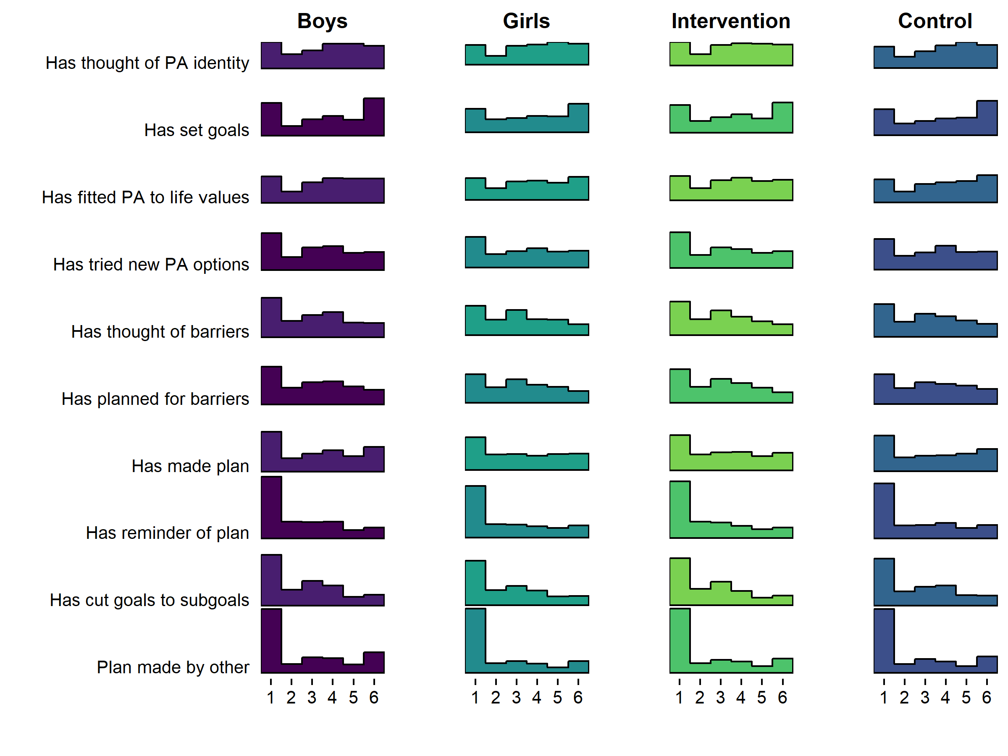

Figure 5 Histogram drawn with R package ggridges(code available at LINK), showing self-reported use of agreement-dependent BCTs (1 = Not at all true … 6 = Completely true).

## Demonstration of network analysis

Figure 6 shows a LASSO regularised mixed graphical model of BCT use, motivation and the two MVPA measures. We can observe, that after taking into account all the other nodes in the network and regularising small connections to zero, autonomous motivation appears to serve as a link between many BCTs and MVPA; In fact, only having a plan made by someone else, and having tried out new ways to be physically active (during the past three weeks), are directly connected to either of the MVPA nodes. In addition, certain BCTs are coupled particularly closely: Strong links exist between goal setting and having a plan made by oneself, between identifying barriers and planning to overcome them, and between setting goals and having a plan to implement PA. We can also see a triad, where thinking about positive consequences is connected to comparing actualised PA with one’s PA goal, through having thought of personal reasons to do PA, as well as less strongly coupled social support and having made changes at home. These types of close connections are often indicative of underlying latent variables (REF: EIKO), although in this case it might also be an order effect, as all items but having thought about positive consequences, were subsequent in the questionnaire.

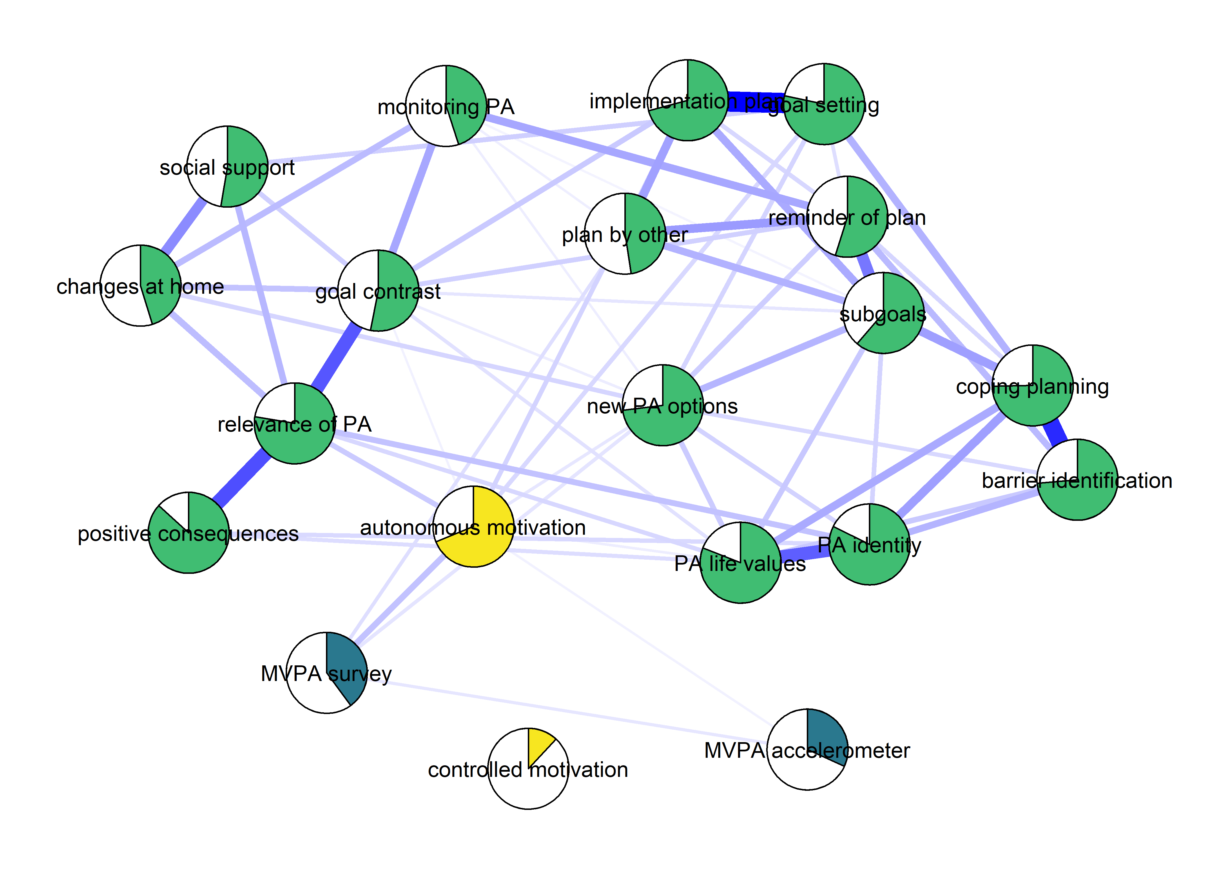

Figure 6 Mixed graphical model with LASSO regularisation and model selection by EBIC. Network models drawn with packages mgm and qgraph (code available at LINK). Blue lines indicate positive relationships. Plot shows the conditional dependence relationships between the variables of interest (edges which connect nodes), which can be interpreted akin to partial correlations. Pies depict means as proportion of theoretical maximum (in the case of accelerometer-measured MVPA, mean as proportion of highest observed value); BCTs and controlled motivation are dichotomised (see Methods).

# Conclusions

This study investigated the baseline characteristics of the Let’s Move It trial cohort, making use of modern tools to exhaustively report the analyses performed and the analytical choices made. We found high levels of sedentary behaviour in the sample, with heterogeneity among educational tracks. MVPA, motivation and BCT use were modeled as a network, which highlighted the relevance of autonomous motivation in associations between PA and BCT use.

Contrary with both international and Finnish evidence, girls performed more PA than boys in this sample. This is due to the practical nurse track being most active and mostly female; i.e. after accounting for track, no meaningful gender differences in accelerometer-measured MVPA could be seen. Further, boys reported doing more MVPA than girls, and the accelerometer-measurement implied they were also more sedentary and interrupted sitting less often. Intervention and control groups were similar in their accelerometer-measured MVPA. This observation supports the decision of pairing educational tracks in randomisation, such that all tracks were represented in both arms.

To our knowledge, this is one of the first studies to measure the use of potential behaviour change techniques comprehensively already at the trial baseline. As can be expected, many people indeed do use BCTs even before the intervention takes place. The results reveal that in the past three weeks, many participants had not used self-regulation related BCTs such as planning, problem solving or goal setting, which on the other hand have been indicated to be useful techniques for PA self-management [55].

Comprehensive, transparent reporting of results leads to a vast amount of information to be presented; visual exposition is thus vital. Visualising distributions makes it salient, how much variability there is among study participants, as well as how we should be wary of applying statistical techniques which rely on distributional assumptions.

The results of the network analysis highlight, how the effect of most naturally occurring behaviour change techniques on MVPA -- exceptions including having a plan made by someone else, and trying out new forms of PA -- can be mediated via autonomous motivation. This finding, if corroborated in longitudinal data, would support the theoretical framework of the intervention, which held autonomy support and behavioural experiments at the forefront. So far, network models have been largely used as a tool for exploring empirical relationships among variables, often with little existing theory (REFS). One could understand this as the first generation of network papers in psychology, and there have been recent calls for a second generation that is confirmatory in nature, and based on existing theories of relationships among biopsychosocial variables (Fried & Cramer, 2017).

Although some variables such as intention showed relatively high baseline levels in a large number of participants, we do not expect obvious ceiling effects to emerge in the PA psychosocial determinants. Due to the phenomenon of the practical nurse track being most active and mostly girls, potential gender differences in intervention results should be interpreted with caution.

The study and the LMI trial has a number of strengths, and will provide important information regarding ways to influence adolescent activity behaviour. Firstly, the recruitment of the baseline sample was successful , with only x% **NELLI** of participants refusing to participate - this number has been considerably higher in other studies in this target group. Secondly, the study used also objective measures of PA and SB, shedding additional light to activity patterns, which has been commonly studied with self-reports only. Third, we have demonstrated state-of-the-art opportunities to visualise data and make it more understandable, and provided code as well as references to R packages, which we hope the reader will be able to make use of.

The study also has limitations. It should be noted that the 7-day accelerometry, even with more than 4 days of over 10 hours wear time, is still an approximation of a participant’s true habitual physical activity and sedentary behaviour in their daily life – not an errorless measure of it, and does not capture all forms of activity. The questionnaire to measure the BCTs was not validated and it

In the network model used, regularization techniques are applied to remove spurious relations and control for multiple testing (for an in-depth tutorial on such regularized network models, see REF). At the same time, these networks estimate relations that are akin to partial correlations to derive the conditional dependence structure among variables. Potential pitfalls of these models and their application have been discussed elsewhere in detail (Fried & Cramer 2017 Perspectives; also: REF). Most importantly, in social networks one can include all relevant nodes (i.e. individuals) in the network. This is not so in biopsychosocial networks, where the question of what items to include has turned out to be a challenging question. After all, relations among items are often interpreted as putative causal pathways (although many other interpretations exist, see Epskamp & Fried 2018 Psych Methods), which means one should not include two variables that are simply two indicators of the same construct. Another important challenge is that one should not aim to control statistically for common effects, also known as colliders (in any regression, and also in network models that are based on regressions), but that it can be challenging to determine if a given variable is a collider [footnote: “If the true model is that A and B both cause C, C is a collider. If one controls for C in the model, a negative relation between A and B will emerge where no relation exists in the true model.”)

The type of supplement used for this manuscript allows for presenting a lot, but not all, information due to resource considerations. One of the reader groups not fully considered are researchers and educators, who wish to use this data to guide intervention design. We would like to point out that the results, like most of the research in the area, only provide a group-level snapshot of a wide variety of constantly unfolding dynamic processes. Few individual participants are described by the group-level summary statistics: In fact, using Daniels’ [57] definition of an “approximately average individual” as falling in the middle 30% of the range of values, only 2% of participants can be considered “average” on all of the primary outcome measures (see supplement plots, section “Informativeness of averages”). Intervention designers looking at this cohort to choose to-be-targeted determinants for their study, may want to consider applying clustering techniques on the data once it becomes publicly available. Still, and especially when processes are considered, group-level data does not inform the individual-level mechanisms of action in the case of non-ergodic systems, and hence the agreement between features of these two levels should be investigated (REF A Fisher 2018).

In conclusion, this analysis of baseline data from the Let’s Move It intervention trial indicates that randomization did not result in highly disproportionate groups, i.e. the differences between control and intervention groups were minimal – although, in the case of complex systems, even small differences may proliferate and lead to group imbalances [58]. It also has shown, that the vocational school students in Finland are hardly a homogenous group, but differ in many regards by their chosen educational track. Finally, graphical methods of presenting descriptive data are an important addition to traditional tables displaying means and standard deviations, and transparent sharing of analyses and analytical choices is imperative for increasing confidence in research findings.

### List of abbreviations

MVPA

### Declarations

### Ethics approval and consent to participate

The research proposal was reviewed by the Ethics Committee for Gynaecology and Obstetrics, Pediatrics and Psychiatry of the Hospital District of Helsinki and Uusimaa (decision number 367/13/03/03/2014).

### Availability of data and materials

The analysis data will be available at [OSF storage] on 1st January 2019. All analyses and code are available at <https://git.io/fNHuf> (permalink at [REF], repository at [REF]).

### Competing interests

The authors declare that they have no competing interests.

### Authors’ contributions

MH wrote the analysis code, including the full online supplement, formulated the initial draft of the manuscript and revised in collaboration of co-authors. TV was responsible for planning and analysing the PA and SB measured from data collected with accelerometer. All authors read and approved the final manuscript.

### Funding

MH was supported by Academy of Finland (grant number 295765). NH was supported by an Academy of Finland Research Fellowship (grant number 285283). The data were collected in a project funded by Ministry for Education and Culture, Sports Science projects (grant number OKM/81/626/2014).

### Acknowledgements

We would like to thank participating schools, their staff and students, as well as the numerous people who have helped in study design and data collection.

# References

1. Elgar FJ, Pförtner T-K, Moor I, De Clercq B, Stevens GWJM, Currie C. Socioeconomic inequalities in adolescent health 2002–2010: A time-series analysis of 34 countries participating in the Health Behaviour in School-aged Children study. The Lancet. 2015;385:2088–95. doi:[10.1016/S0140-6736(14)61460-4](https://doi.org/10.1016/S0140-6736(14)61460-4).

2. Dieleman JL, Sadat N, Chang AY, Fullman N, Abbafati C, Acharya P, et al. Trends in future health financing and coverage: Future health spending and universal health coverage in 188 countries, 2016–40. The Lancet. 2018;391:1783–98.

3. Husu P, Vähä-Ypyä H, Vasankari T. Objectively measured sedentary behavior and physical activity of Finnish 7-to 14-year-old children–associations with perceived health status: A cross-sectional study. BMC public health. 2016;16:338.

4. Mäkelä K, Kokko S, Kannas L, Villberg J, Vasankari T, Heinonen JO, et al. Physical Activity, Screen Time and Sleep among Youth Participating and Non-Participating in Organized Sports: The Finnish Health Promoting Sports Club (FHPSC) Study. Advances in Physical Education. 2016;6.

5. van Sluijs EM, Skidmore PM, Mwanza K, Jones AP, Callaghan AM, Ekelund U, et al. Physical activity and dietary behaviour in a population-based sample of British 10-year old children: The SPEEDY study (Sport, Physical activity and Eating behaviour: Environmental Determinants in Young people). BMC public health. 2008;8:388.

6. Hankonen N, Heino MT, Kujala E, Hynynen S-T, Absetz P, Ara’ujo-Soares V, et al. What explains the socioeconomic status gap in activity? Educational differences in determinants of physical activity and screentime. BMC public health. 2017;17:144. <https://bmcpublichealth.biomedcentral.com/articles/10.1186/s12889-016-3880-5>. Accessed 27 May 2017.

7. Hynynen S-T, van Stralen MM, Sniehotta FF, Ara’ujo-Soares V, Hardeman W, Chinapaw MJM, et al. A systematic review of school-based interventions targeting physical activity and sedentary behaviour among older adolescents. Int Rev Sport Exerc Psychol. 2016;9:22–44.

8. Rogers PJ. Using Programme Theory to Evaluate Complicated and Complex Aspects of Interventions. Evaluation. 2008;14:29–48.

9. Moore GF, Audrey S, Barker M, Bond L, Bonell C, Hardeman W, et al. Process evaluation of complex interventions: Medical Research Council guidance. BMJ. 2015;350:h1258.

10. Hankonen N, Heino MTJ, Hynynen S-T, Laine H, Ara’ujo-Soares V, Sniehotta FF, et al. Randomised controlled feasibility study of a school-based multi-level intervention to increase physical activity and decrease sedentary behaviour among vocational school students. International Journal of Behavioral Nutrition and Physical Activity. 2017;14.

11. Hankonen N, Heino MTJ, Araujo-Soares V, Sniehotta FF, Sund R, Vasankari T, et al. “Let’s Move It” a school-based multilevel intervention to increase physical activity and reduce sedentary behaviour among older adolescents in vocational secondary schools: A study protocol for a cluster-randomised trial. BMC Public Health. 2016;16:451–66.

12. Cleveland WS. Visualizing data. Hobart Press; 1993.

13. Tukey JW. Exploratory data analysis. Reading, Mass.; 1977.

14. Board of Governors of the Federal Reserve System, Chang AC, Li P. Is Economics Research Replicable? Sixty Published Papers from Thirteen Journals Say "Usually Not". Finance and Economics Discussion Series. 2015;2015:1–26.

15. Bond TN, Lang K. The Sad Truth About Happiness Scales: Empirical Results. Working Paper. National Bureau of Economic Research; 2018.

16. Gigerenzer G. Statistical Rituals: The Replication Delusion and How We Got There. Advances in Methods and Practices in Psychological Science. 2018;2515245918771329.

17. Kepes S, McDaniel MA. How Trustworthy Is the Scientific Literature in Industrial and Organizational Psychology? Industrial and Organizational Psychology. 2013;6:252–68.

18. Nosek BA, Ebersole CR, DeHaven AC, Mellor DT. The preregistration revolution. Proceedings of the National Academy of Sciences. 2018;201708274.

19. Nosek BA, Spies JR, Motyl M. Scientific Utopia II. Restructuring Incentives and Practices to Promote Truth Over Publishability. Perspectives on Psychological Science. 2012;7:615–31.

20. Simmons JP, Nelson LD, Simonsohn U. False-Positive Psychology Undisclosed Flexibility in Data Collection and Analysis Allows Presenting Anything as Significant. Psychological Science. 2011;22:1359–66.

21. Smaldino PE, McElreath R. The natural selection of bad science. Open Science. 2016;3:160384.

22. Stodden V, Seiler J, Ma Z. An empirical analysis of journal policy effectiveness for computational reproducibility. Proceedings of the National Academy of Sciences. 2018;115:2584–9.

23. Nosek BA, Errington TM. Reproducibility in cancer biology: Making sense of replications. Elife. 2017;6:e23383.

24. R Core Team. R: A Language and Environment for Statistical Computing. Vienna, Austria: R Foundation for Statistical Computing; 2017.

25. Fagt S, Andersen LF, Anderssen SA, Becker W, Borodulin K, Fogelholm M, et al. Nordic Monitoring of diet, physical activity and overweight : Validation of indicators. Nordic Council of Ministers; 2012.

26. Vähä-Ypyä H, Vasankari T, Husu P, Suni J, Sievänen H. A universal, accurate intensity-based classification of different physical activities using raw data of accelerometer. Clinical physiology and functional imaging. 2015;35:64–70.

27. Vähä-Ypyä H, Vasankari T, Husu P, Mänttäri A, Vuorimaa T, Suni J, et al. Validation of cut-points for evaluating the intensity of physical activity with accelerometry-based mean amplitude deviation (MAD). PLoS One. 2015;10:e0134813.

28. Tremblay MS, Aubert S, Barnes JD, Saunders TJ, Carson V, Latimer-Cheung AE, et al. Sedentary Behavior Research Network (SBRN) process and outcome. International Journal of Behavioral Nutrition and Physical Activity. 2017;14:75.

29. Vähä-Ypyä H, Husu P, Suni J, Vasankari T, Sievänen H. Reliable recognition of lying, sitting, and standing with a hip-worn accelerometer. Scandinavian Journal of Medicine & Science in Sports. 2018;28:1092–102.

30. RStudio Team. RStudio: Integrated Development Environment for R. 2016.

31. R Core Team. R: A language and environment for statistical computing. Vienna, Austria: R Foundation for Statistical Computing; 2018. <https://www.R-project.org/>.

32. Dalege J, Borsboom D, van Harreveld F, van den Berg H, Conner M, van der Maas HLJ. Toward a formalized account of attitudes: The Causal Attitude Network (CAN) model. Psychological Review. 2016;123:2–22.

33. Dalege J, Borsboom D, Harreveld F, Waldorp LJ, Maas HL. Network structure explains the impact of attitudes on voting decisions. Scientific reports. 2017;7:4909.

34. Mõttus R, Allerhand M. Why do traits come together? The underlying trait and network approaches. SAGE handbook of personality and individual differences. 2017;1:1–22.

35. Van Der Maas H, Kan K-J, Marsman M, Stevenson CE. Network Models for Cognitive Development and Intelligence. 2017.

36. Fried EI, van Borkulo CD, Cramer AO, Boschloo L, Schoevers RA, Borsboom D. Mental disorders as networks of problems: A review of recent insights. Social Psychiatry and Psychiatric Epidemiology. 2017;52:1–10.

37. Briganti G, Kempenaers C, Braun S, Fried EI, Linkowski P. Network analysis of empathy items from the interpersonal reactivity index in 1973 young adults. Psychiatry Research. 2018;265:87–92.

38. Dalege J, Borsboom D, van Harreveld F, van der Maas HL. Network analysis on attitudes: A brief tutorial. Social psychological and personality science. 2017;8:528–37.

39. Epskamp S, Fried EI. A Tutorial on Regularized Partial Correlation Networks. Psychological Methods. 2018. doi:[10.1037/met0000167](https://doi.org/10.1037/met0000167).

40. Epskamp S, Borsboom D, Fried EI. Estimating Psychological Networks and their Stability: A Tutorial Paper. arXiv preprint arXiv:160408462. 2016.

41. Costantini G, Epskamp S, Borsboom D, Perugini M, Mõttus R, Waldorp LJ, et al. State of the aRt personality research: A tutorial on network analysis of personality data in R. Journal of Research in Personality. 2015;54:13–29.

42. Costantini G, Richetin J, Preti E, Casini E, Epskamp S, Perugini M. Stability and variability of personality networks. A tutorial on recent developments in network psychometrics. Personality and Individual Differences. 2017.

43. Fried EI, Cramer AO. Moving forward: Challenges and directions for psychopathological network theory and methodology. Perspectives on Psychological Science. 2017;12:999–1020.

44. Borsboom D, Mellenbergh GJ, van Heerden J. The theoretical status of latent variables. Psychological Review. 2003;110:203–19.

45. Bringmann LF, Eronen MI. Don’t blame the model: Reconsidering the network approach to psychopathology. Psychological review. 2018;125:606–33.

46. Tibshirani R. Regression shrinkage and selection via the lasso: A retrospective. Journal of the Royal Statistical Society: Series B (Statistical Methodology). 1996;73:273–82.

47. Haslbeck JMB, Waldorp LJ. How well do network models predict observations? On the importance of predictability in network models. Behavior Research Methods. 2018;50:853–61.

48. Haig BD. Tests of Statistical Significance Made Sound. Educational and Psychological Measurement. 2016.

49. Nickerson RS. Null hypothesis significance testing: A review of an old and continuing controversy. Psychological Methods. 2000;5:241–301.

50. de Groot AD. The meaning of “significance” for different types of research [translated and annotated by Eric-Jan Wagenmakers, Denny Borsboom, Josine Verhagen, Rogier Kievit, Marjan Bakker, Angelique Cramer, Dora Matzke, Don Mellenbergh, and Han L. J. van der Maas]. Acta Psychologica. 2014;148:188–94.

51. Lakens D, Adolfi FG, Albers CJ, Anvari F, Apps MAJ, Argamon SE, et al. Justify your alpha. Nature Human Behaviour. 2018;2:168–71.

52. Lai MHC, Kwok O-m. Estimating Standardized Effect Sizes for Two- and Three-Level Partially Nested Data. Multivariate Behavioral Research. 2016;51:740–56.

53. Lai MHC, Kwok O-m, Hsiao Y-Y, Cao Q. Finite population correction for two-level hierarchical linear models. Psychological methods. 2018;23:94.

54. Kievit RA, Frankenhuis WE, Waldorp LJ, Borsboom D. Simpson’s paradox in psychological science: A practical guide. Frontiers in Psychology. 2013;4.

55. Michie S, Abraham C, Whittington C, McAteer J, Gupta S. Effective techniques in healthy eating and physical activity interventions: A meta-regression. Health Psychology. 2009;28:690–701.

56. Crutzen R, Peters G-JY, Noijen J. Using Confidence Interval-Based Estimation of Relevance to Select Social-Cognitive Determinants for Behavior Change Interventions. Frontiers in Public Health. 2017;5.

57. Daniels GS. The" Average Man"? AIR FORCE AEROSPACE MEDICAL RESEARCH LAB WRIGHT-PATTERSON AFB OH; 1952.

58. Rickles D. Causality in complex interventions. Medicine, Health Care, and Philosophy. 2009;12:77–90.